**Title of Work**

**Profex's Warzone**

**Field of Study**

**Informational Technologies**

**Year of Creation**

**2024**

# Table of content

**Table of content 2**

**Aim of the Work 3**

**Software 3**

**Installation Steps 3**

**Game Description 3**

Story 3

Characters 3

Gunplay 4

**Mechanics 4**

**Maps 4**

**Manual 5**

Controls 5

Joining a server 5

Server Hosting 5

Conclusion 6

# 

# Aim of the Work

The objective of this project is to develop a multiplayer 2D action game in Java for the seminar project. The game will feature deathmatch-style gameplay where players compete for the highest number of kills. Key elements include multiple maps, weapon pickups, and hosting own servers.

# Software

The game requires Java 19.0.2.

The development environment used was IntelliJ IDEA.

# Installation Steps

Download the game or server jar from the [GitHub repository](https://github.com/Profex993/Profexs-Warzone).

Install Java 19.0.2 from the [official Oracle website](https://www.oracle.com/java/technologies/javase/jdk19-archive-downloads.html).

Done.

# Game Description

## Story

Players take on the roles of mercenaries fighting in a war zone.

## Characters

Players can choose from different avatars, representing diverse mercenaries.



## 

## 

## Gunplay

The game offers many weapons which players can find on the map.



# Mechanics

Weapons can be found scattered across the map, and players respawn at random locations after being killed. Players can display a leader board which displays the current standings of players. Various game elements can be controlled in the server code by changing variables in class ServerConstants.

# Maps

The only map available is "Crossfire," which includes a bunker, heliport, destroyed tunnel, and various houses. More maps are planned for future updates. Eventually, players might be able to create their own maps.

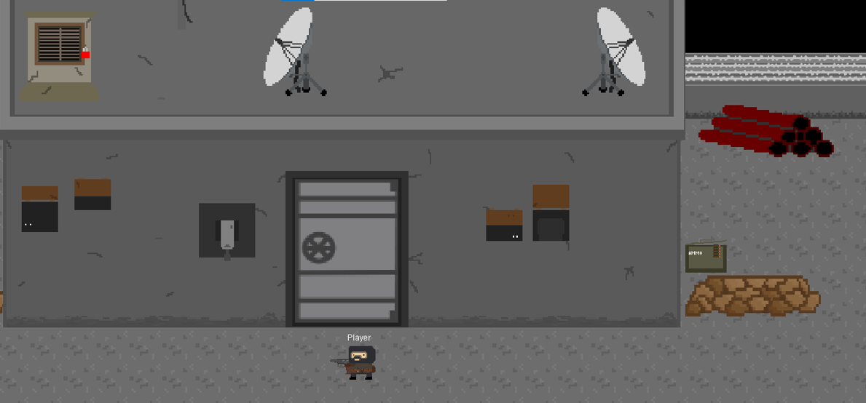

# Manual

## Controls

The game is controlled using the following keys and actions:

Movement: W, A, S, D

Shoot: Left-click

Interact: Right-click

Leaderboard: T key

## Joining a server

When launching the game, You have to select an IP address and port on which the server is running. Then click join and select your user name and avatar in the upper part of the window. Then click join and play.

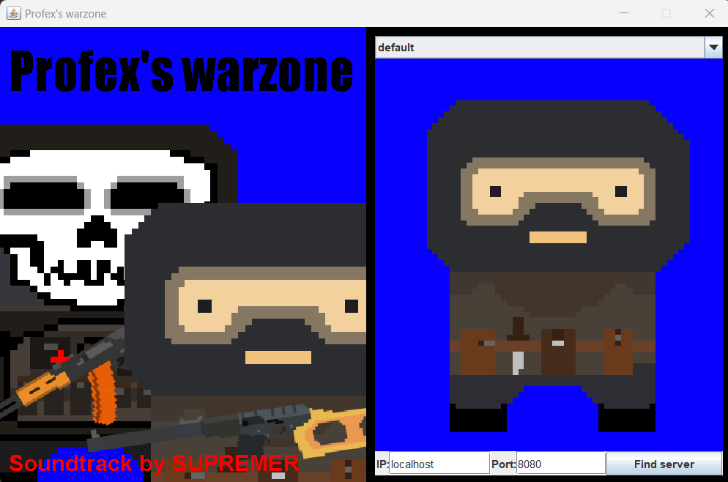

## Server Hosting

To host a server, run the server application, select a port, and adjust firewall settings if necessary. The server console supports commands accessible through the help command.

## Conclusion

Creating Profex's Warzone involved designing engaging multiplayer mechanics, developing and ensuring smooth server hosting. Developing the game also involved a lot of graphic and sound design. Some features of the game, like various maps, are missing due to time pressure. Despite challenges in optimizing network performance and balancing gameplay, the project successfully provides an exciting multiplayer experience.